Click on WFID
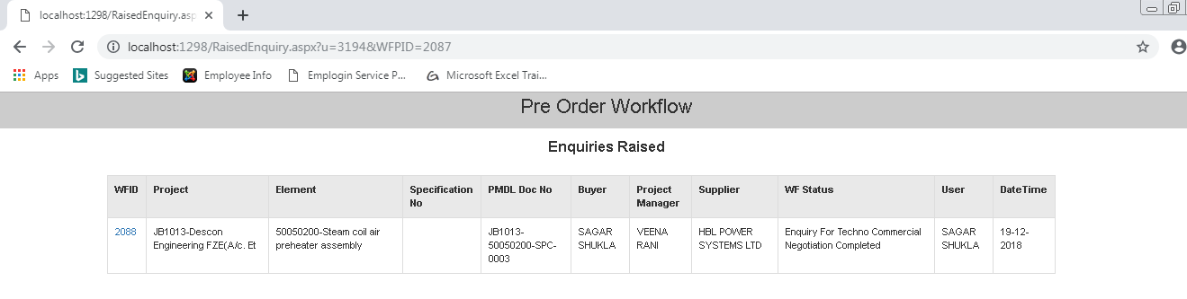
Click Here
Status changed

- In the screen that appear Click on Notes.
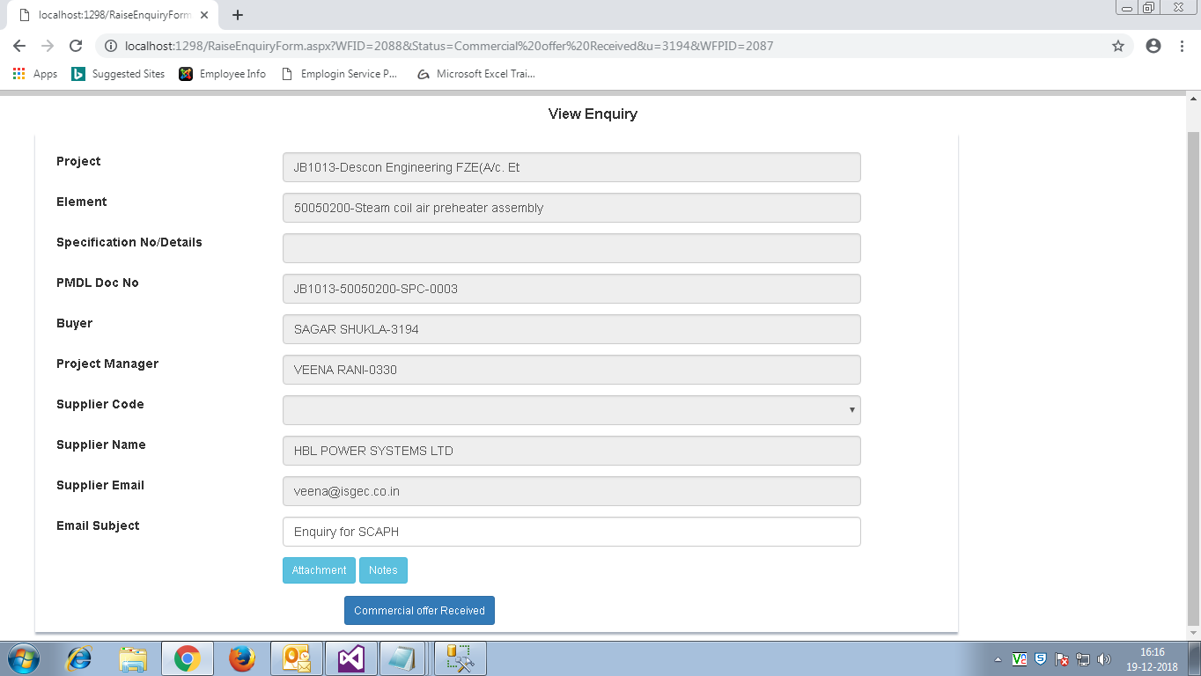
Notes

90) Inform to supplier thru notes facility as explained earlier to submit Commercial Offer , this negotiation between supplier & Buyer will take place thru Notes functionality, once buyer is convinced he will mark the Enquiry as Commercial Offer Received.
Click Here
91)
Click Here
91)

- In the screen that opens up the Status will change to Commercial Offer Received.
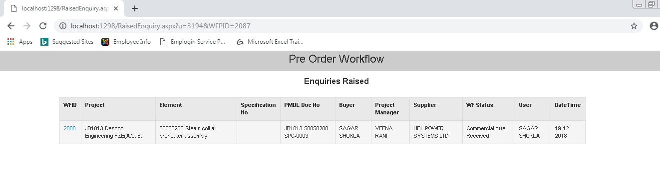
Status Changed
91)

- This Process will continue for all offers from Supplier and its commercial Offer Closure.

